# Importing Data into SPSS

Shaik.Hameeda Parvin~G34 PYTHON

Open the Teaching Ratings data in SPSS, by clicking on ****File > Open...**** and navigating to your ****teacherratings.sav**** file located somewhere on your computer. Observe the loaded dataset.

 With the data loaded, near the bottom of the window, switch from Data View to ****Variable View****.

 Locate ****eval**** variable. Notice how the "****Label****" value is empty, which should describe what the ****eval**** variable is about. Double-click on the empty cell and enter a meaningful description, like "****Teaching Evaluation Score****".

Create a descriptive statistics table to calculate the min and max values for the Age variable.

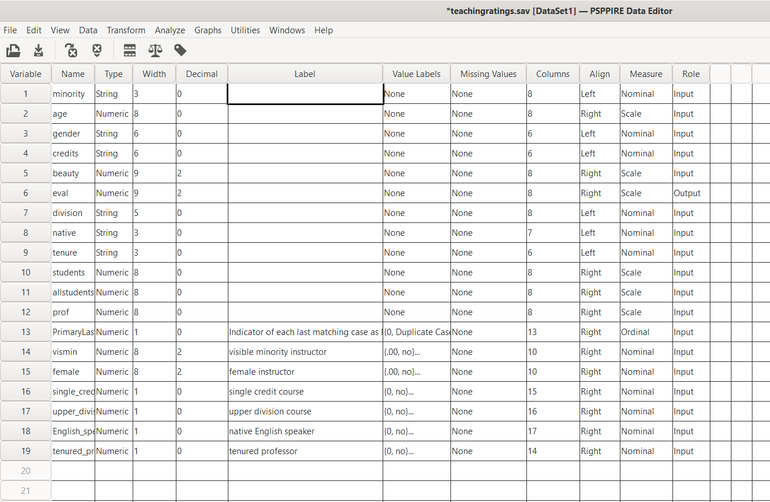

OUTPUT:::::

